**Project Report: Chinese Debt Trap Analysis**

**1. INTRODUCTION**

**1.1 Project Overview**

The project aimed to analyze Chinese debt-trap diplomacy by exploring money lending patterns globally. Utilizing Business Intelligence tools, the study delved into trends, defaults, and the geopolitical impact of Chinese loans.

**1.2 Purpose**

The project sought to provide comprehensive insights into Chinese lending practices, aiding stakeholders in understanding potential risks and impacts on borrower countries.

**2. LITERATURE SURVEY**

**2.1 Existing Problem**

Existing literature highlights concerns over China's debt-trap diplomacy. This project contributes by conducting a detailed analysis using data analytics to uncover patterns and implications.

**2.2 Problem Statement Definition**

The project addresses the question: "How do Chinese lending patterns and geopolitical clauses impact countries globally?"

**3. IDEATION & PROPOSED SOLUTION**

**3.1 Empathy Map Canvas**

An empathy map was created to understand stakeholders' perspectives, needs, and pain points regarding Chinese lending practices.

**3.2 Ideation & Brainstorming**

Team collaboration resulted in the conceptualization of data analysis techniques, focusing on lending patterns and geopolitical clauses.

**4. REQUIREMENT ANALYSIS**

**4.1 Functional Requirements**

- Analyze lending patterns over time.

- Identify and visualize geopolitical clauses in loan agreements.

**4.2 Non-Functional Requirements**

- Ensure data accuracy and reliability.

- Develop user-friendly visualizations for easy interpretation.

**5. PROJECT DESIGN**

**5.1 Data Flow Diagrams & User Stories**

Utilizing data flow diagrams and user stories to guide the development process, ensuring alignment with project objectives.

**5.2 Solution Architecture**

The technical architecture was designed to support data analytics and visualization requirements efficiently.

**6. PROJECT PLANNING & SCHEDULING**

**6.1 Technical Architecture**

An overview of the technical architecture, detailing the tools and technologies used for data analysis and visualization.

**6.2 Sprint Planning & Estimation**

Sprints were planned, and story points were estimated based on a 4-member team and a 1-month timeframe for completion.

**6.3 Sprint Delivery Schedule**

The project timeline was structured into sprints with planned and actual delivery dates.

**7. PERFORMANCE TESTING**

**7.1 Performance Metrics**

Performance testing metrics were established to evaluate the efficiency and responsiveness of the solution.

**8. RESULTS**

**8.1 Output Screenshots**

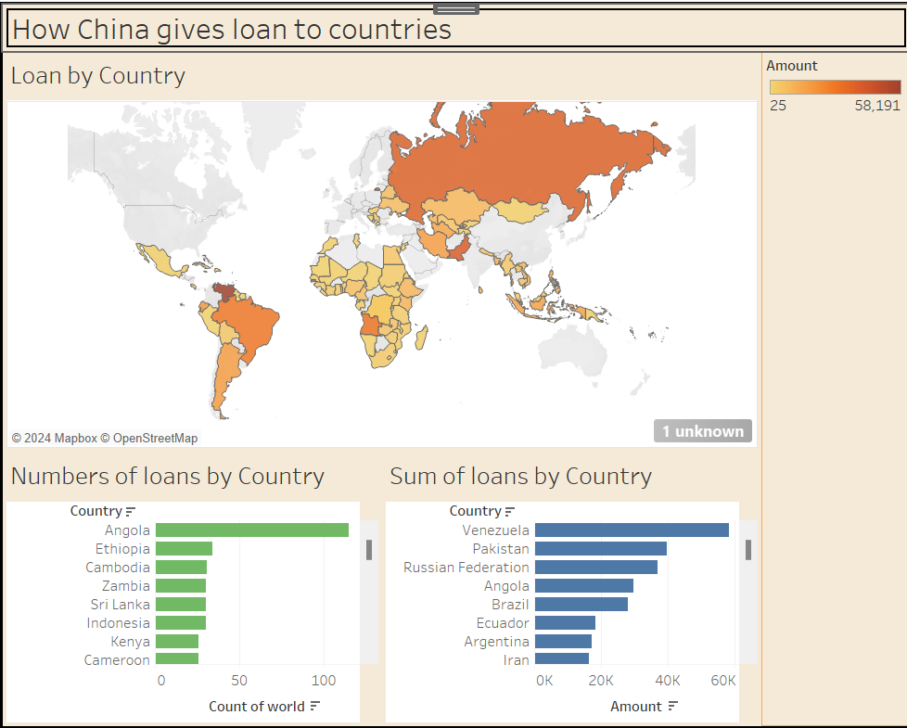

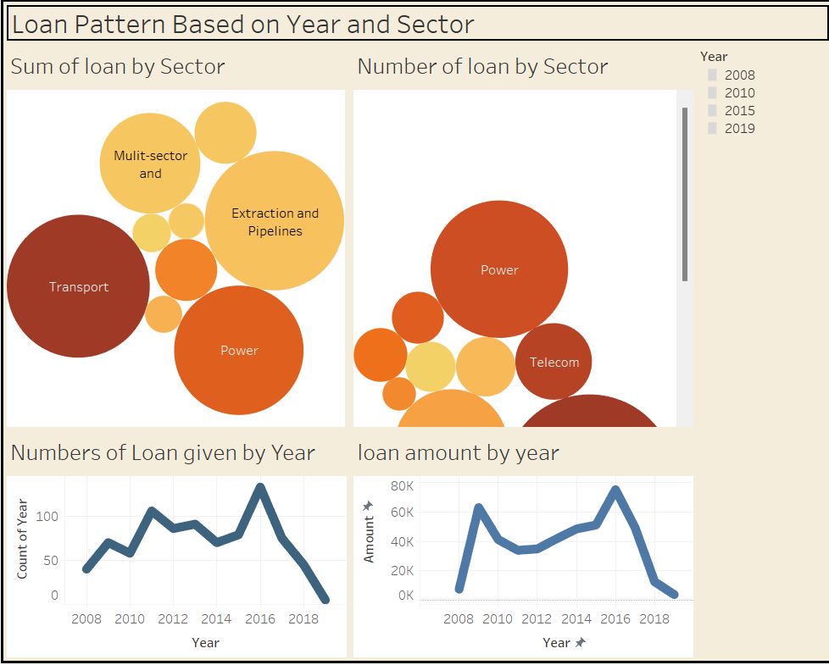

**9. ADVANTAGES & DISADVANTAGES**

A balanced assessment of the advantages and disadvantages observed during the project.

**10. CONCLUSION**

Summarize key findings and insights obtained from the project, emphasizing their relevance to the initial problem statement.

**11. FUTURE SCOPE**

Highlight potential areas for further research and development in this domain.

**12. APPENDIX**

**Source Code**

<https://github.com/smartinternz02/SI-GuidedProject-587365-1696743847/blob/main/index.html>

**GitHub & Project Demo Link**

[**https://github.com/smartinternz02/SI-GuidedProject-587365-1696743847/blob/main/index.html**](https://github.com/smartinternz02/SI-GuidedProject-587365-1696743847/blob/main/index.html)